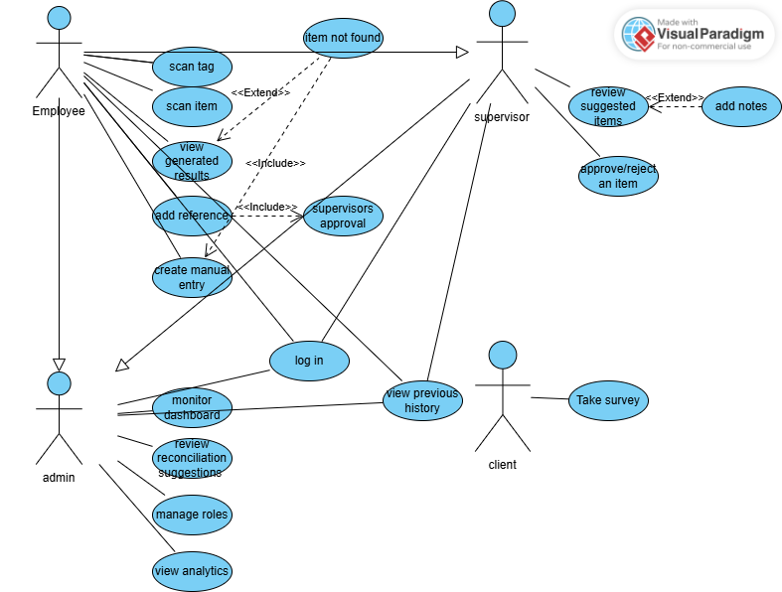

Use case name: Log in
Actors: Employee, Supervisor, Admin
Brief Description: User authenticates to access the system
Basic Flow:
1.System prompts for id and password
2. User enters id and password
3. System verifies credentials
4.User is taken to their home screen
Alternative Flow: Invalid credentials => sys shows error => user retries
Pre-Conditions: User has an account
Post-Conditions: User session is active
Shared Use cases:

Use case name: View previous history
Actors: Employee, Supervisor, Admin
Brief Description: User reviews their past actions
Basic Flow:
1.Employee can view past scans, entries, and references
2. Supervisor can view past approvals/rejections and notes
3. Admin can view past reconciliations, merges and actions done by supervisors and employees
Alternative Flow: none
Pre-Conditions: User logged in
Post-Conditions: History viewed

Employee Specific Use Cases:
Use case name: Scan Tag/Item
Actors: Employee, Supervisor, Admin
Brief Description: Employee scans a product tag or item photo to retrieve AI-generated results
Basic Flow:
1. Employee captures item or tag and adds manually extra description if needed
2.Employee presses “Scan”
3. System redirects to website and displays results (image, name, price suggestion, unique ref, confidence level).
Alternative Flow:
Item Not Found => Employee can rescan, broaden search, or create manual entry
Pre-Conditions: App installed, camera available
Post-Conditions: User redirected to website with results

Use case name: Create Manual Entry
Actors: Employee, Supervisor, Admin
Brief Description: Enter product details when item is not found
Basic Flow:
1. Employee selects “create manual entry”
2.Employee fills product info
3. Submits entry
4.System stores as pending for supervisors review
Alternative Flow:
Missing mandatory fields => System highlights and requires correction.
Pre-Conditions: item is not found and user has to choose manual entry
Post-Conditions: pending entry created for supervisor’s approval

Use case name: Add Reference
Actors: Employee, Supervisor, Admin
Brief Description: Add a new reference for an item
Basic Flow:
1. Employee selects “Add Reference” from results
2.System routes new reference to Supervisor
Alternative Flow:
Validation errors =>System asks employee to correct
Pre-Conditions: Employee has scanned an item/tag
Post-Conditions: Reference awaiting supervisors approval

Supervisor Specific Use Cases:
Use case name: Review Suggested Item
Actors: Supervisor, Admin
Brief Description: Evaluate AI-suggested or employee submitted items.
Basic Flow:
1. Supervisor opens pending queue
2.Views product details (image, name, price, reference ID)
3.Chooses Approve or Reject
Alternative Flow:
Add Notes => supervisor writes clarifications for context
Edit Details => Supervisor modifies product info then approves
Pre-Conditions: Existing pending items
Post-Conditions: item approved (added to DB), rejected (blocked), or edited + approved

Admin Specific Use Cases:
Use case name: Monitor Dashboard
Actors: Admin
Brief Description: Track system errors, duplicates, and trends
Basic Flow:
1.Admin opens dashboard.
2.Views auto-detected issues and supervisor notes.
Alternative Flow: none
Pre-Conditions: Admin logged in
Post-Conditions: issues surfaced for further action

Use case name: Review Reconciliation Suggests
Actors: Admin
Brief Description: Resolve duplicates or conflicts flagged by system
Basic Flow:
1.Admin opens “Reconciliation Suggestions”
2.Chooses Approve Merge, Reject, or Edit
Alternative Flow:
Add Notes => supervisor writes clarifications for context
Edit Details => Supervisor modifies product info then approves
Pre-Conditions: Suggestions exist.
Post-Conditions: Data merged, corrected, or routed back

Use case name: Manage roles
Actors: Admin
Brief Description: Assign and update user roles
Basic Flow:
1.Admin opens User Management.
2.Selects user, modifies roles.
3.Saves.
Alternative Flow: none
Pre-Conditions: admin privileges active
Post-Conditions: roles updated

Use case name: View Analytics
Actors: Admin
Brief Description: Review error statistics and customer sentiment
Basic Flow:
1. Admin opens Analytics.
2.Views repeated mistakes, error stats, and NLP summary of feedback (% positive/neutral/negative)
Alternative Flow: none
Pre-Conditions: Analytics data exist
Post-Conditions: Insights reviewed

Client Specific Use Cases:
Use case name: Take Survey
Actors: Client
Brief Description: Client answers a short survey about their experience with the PRRS driven process
Basic Flow: 1. Client opens survey
2.System shows brief questions (ratings + optional comments)
3.Client submits
4.System stores response for reporting
Alternative Flow: Survey abandoned/timeout → System saves partial or prompts to retry
Pre-Conditions: Client has access to survey entry point
Post-Conditions: Response saved and is available to Admin under Analytics

